The Friends of Blandford Community Hospital
Registered charity 800 482

Prize Bingo
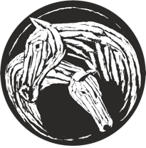

Sponsored by The White Horse Inn, Stourpaine

Thursday 12th September
Doors Open 6.45pm Eyes Down 7.30pm

Dining Room, Blandford Hospital
(Refreshments available)


**10 prize games, special and a cash flyer **

Great Odds - Fantastic Prizes
Further info from the Friends Office on 01258 451456
www.friendsofblandford.org.uk

